4.5: Of the many ways to do this problem, two are presented here.
Geometric: From the law of cosines, the magnitude of the resultant is
The angle between the resultant and dog A’s rope (the angle opposite the side corresponding to the 250-N force in a vector diagram) is then
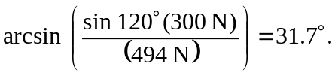
Components: Taking the 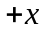-direction to be along dog A’s rope, the components of the resultant are
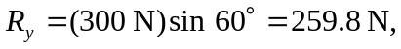
so

